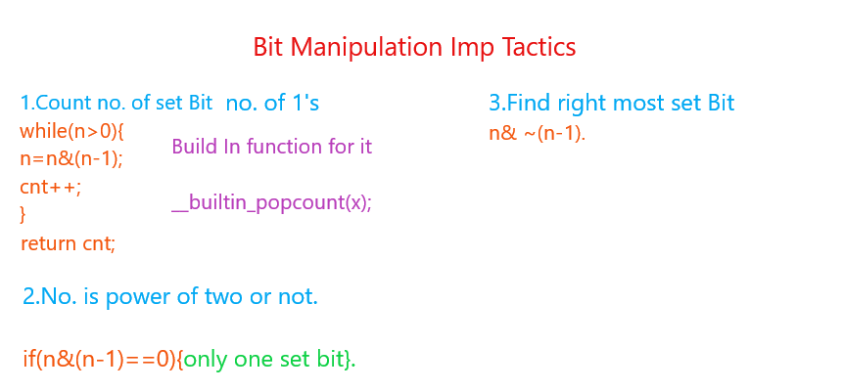

3.No. is power of 4 or not.

bool isPowerOfFour(int n) {

    return !(n&(n-1)) && (n&0x55555555);

    //check the 1-bit location;

}

4. *Number of leading zeroes: __builtin_clz(x)*

  int k2 = __builtin_clz(x);

    cout<< (unsigned int)(k2)<<endl; ;// ** very imp to use unsigned int this will stop printing -ve number.

*Number of trailing zeroes : __builtin_ctz(x)*

  int k2 = __builtin_ctz(x);

    cout<< (unsigned int)(k2)<<endl;// ** very imp to use unsigned int this will stop printing -ve number.

*Number of 1-bits: __builtin_popcount(x)*

int x=64;

   int y = __builtin_popcount(x);

   cout<<y<<endl;

*5.Find right most significant bit or (LSB).*

*int x = n& ~(n-1);*

*6.Find left most significant bit or (MSB)*

int k = __builtin_clz(n); //this will count the no. of leading zeroes

    cout<< (unsigned int)(1<<(31 - k))<<endl;

## 7. Check if a number has bits in an alternate pattern

## . if in n^n>>1 all the bits are set then true else false;

## Int x =101010 ^ (010101) = 111111.

## 

## How to check all bits of a number is set or not.

## If(n== pow(2,__builtin_popcount(x)) -1){

## Py;

## }else{

## Pn; }

8.Imp Properties of xor

x^0 =x;

x^x = 0;

x^y=y^x;

